Tausand

Tempico Software 2.1.0

Software for Tempico TP1004 & TP1204



User’s manual
Rev 1.5
August 8th, 2026

www.tausand.com

Contents
1 Definitions 4
1.1 Sampling time 4
1.2 Edge type 4
1.3 Lifetime measurements 4
1.3.1 Fluorescence lifetime measurements 4
2 Description 5
3 Specifications 5
4 Installation 5
4.1 Windows 5
4.2 Ubuntu 7
4.3 Mac 8
5 Software operation 9
5.1 System configuration 9
5.1.1 Windows 9
5.1.2 Ubuntu 9
5.1.3 Mac 10
5.2 Open the software and select a Tempico device 10
5.3 Channel settings 12
5.4 General settings 14
5.5 TP1200 settings 14
5.6 File path settings 15
5.7 Start-stop histogram measurements 16
5.7.1 Perform a measurement 16
5.7.2 Save data and plots 19
5.8 Lifetime histograms 21
5.8.1 Settings before a measurement 21
5.8.2 Perform a measurement 22
5.8.3 Fitting 23
5.8.4 Save data and plots 25
5.9 Counts estimation 27
5.9.1 Settings for signal measurement 27
5.9.2 Settings before measurement 28
5.9.3 Perform a measurement 31
5.9.4 Save data 36
5.9.5 Save plot 37
5.10 Time stamping 38
5.10.1 Settings before measurements 38
5.10.2 Perform a measurement 40
5.10.3 Save data 44
5.11 Autocorrelation (Fluorescence Correlation Spectroscopy) 45
5.11.1 Settings before measurements 45
5.11.2 Perform a measurement 47
5.11.3 Post-measurement 48
5.11.3.1 Fitting 48
5.11.3.1.1 Gaussian diffusion 48
5.11.3.1.2 Anomalous diffusion 48
5.11.3.1.3 Chemical relaxation 49
5.11.3.1.4 Diffusion with flow 49
5.11.3.1.5 Triplet state correction 49
5.11.3.1.6 Two-component diffusion 49
5.11.3.2 Save data 49
5.12 g$​2​$ (Hanbury Brown and Twiss) 50
5.12.1 Settings before measurements 50
5.12.2 Perform a measurement 51
5.12.3 Post-measurement 52
5.12.3.1 Fitting 52
5.12.3.1.1 Antibunched Gaussian 52
5.12.3.1.2 Antibunched Lorentzian 53
5.12.3.1.3 Bunched Gaussian 53
5.12.3.1.4 Bunched Lorentzian 53
5.12.3.1.5 Three-level system 53
5.12.3.2 Save data 53
6 Technical documentation 54
7 Drivers 54
8 Technical support 54

1 Definitions

Sampling time
The sampling time in an experiment refers to the time window during which data is collected. For example, if we count how many times the laboratory door opens over the course of 2 hours, the sampling time would be 2 hours.

Edge type
The edge type indicates the type of transition that the time-to-digital converter (TDC) must use to start or stop a measurement. There are two main types: rise edge and falling edge. An event arriving at a TDC must be a short-duration pulse that exceeds the device's resolution. Therefore, if the transition goes from a low level (0) to a high level (1), we call it a rise edge. On the other hand, if we want to register an event when the signal transitions from a high level (1) to a low level (0), we call it a falling edge. The Tausand Tempico device allows for configuring the edge type for both the start signal and the stop signals. Below is a time diagram representation with a rise edge configuration for both the start signal (red) and the stop signal (blue).
Now we can see the representation of a falling edge configuration for the start signal (red) and the stop signal (blue).

Lifetime measurements
Lifetime measurements are used to determine how long a molecule, particle, or physical system stays in an excited state before returning to its ground state, or to quantify the duration of a short-lived compound. Most of these measurements are performed by measuring the time difference between two photons.
One of the most widely used techniques for this type of measurement is time-correlated single photon counting (TCSPC). This technique relies on the emission of a pulse from a laser, which acts as a trigger to start the measurement. If the laser's frequency is correct, it partially excites the sample. Subsequently, the sample decays and emits a photon back. Some of these photons are detected by an electronic system, which converts them into electrical pulses. These electrical pulses mark the end of the measurement. The time difference between the start pulse and the stop pulse is mapped onto a histogram. Ultimately, the obtained histogram provides information about the temporal distribution of the sample's exciting state.
Tempico software is capable of capturing data in techniques that involve the emission and detection of pulses, such as in single photon counting. Several lifetime measurement methods can be applied depending on the type of analysis being performed.

Fluorescence lifetime measurements
This technique involves the use of a fluorophore to measure the time it takes to return to the ground state from the excited state. It is primarily used for the analysis of chemical and biological samples. The analysis is conducted by creating an environment with a fluorophore, and any change in the sample causes a modification in the fluorescent environment. In this way, temporal differences associated with interactions or changes in the sample can be obtained.

Description
Tempico Software is designed to facilitate the use of the Tausand Tempico TP1004 and TP1204 devices. It is a graphical interface that allows for time histogram measurements and lifetime measurements. From the software, it is possible to configure the device, as well as save the measurement data and generated graphs in various text and image formats, respectively. Additionally, Tempico Software provides extra functions, such as creating custom adjustments for certain graphs, and allowing monitoring the device to ensure the measurement is being performed correctly.

Specifications
Tempico software is designed to run on devices with low requirements, allowing any laboratory to use it. The minimum requirements for Tempico Software to function are as follows:
- OS: Windows 7 Home Premium, Windows 7 Professional, Windows 7 Ultimate, Ubuntu 20.04, mac OS Big Sur
- CPU: Intel Pentium Dual-Core E5200
- RAM: 1 GB
- Storage: 500 MB available
For measurements with large data sets or long durations (greater than 6 hours), the performance of Tempico Software may decrease. However, on higher-performance devices, this issue is mitigated.

Installation

Windows
The first step is to download the software from the Tausand website: https://www.tausand.com/downloads/. From this page, an executable file will be downloaded, which should be run to complete the installation by following the steps provided.
When opening the installer, it will request permission to run, to which we should respond affirmatively. After that, a window will appear asking us to select the installation path. We can choose the desired path; by default, the software will be installed in the Program Files folder.
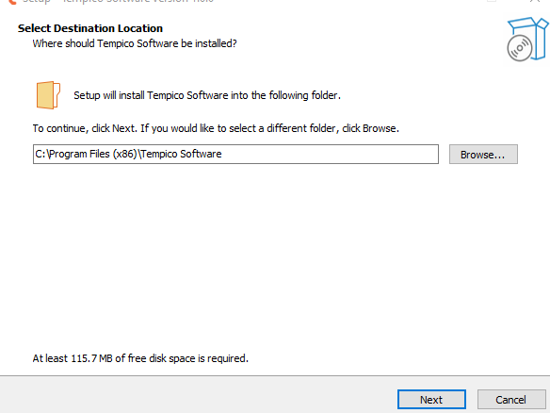
Next, we will be asked if we want to create a shortcut on the desktop. To do so, we should check the corresponding box.
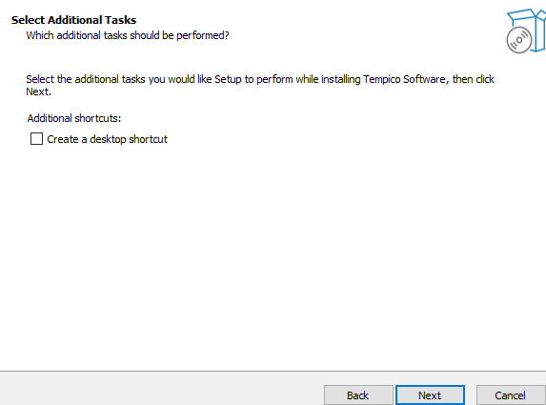
After completing these two steps, a tab will open showing us the installation path, allowing us to verify it before proceeding with the installation.
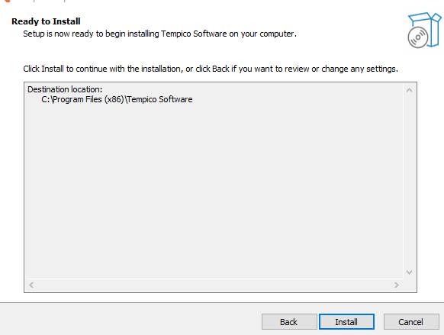
Once the installation process is complete, we can click "Finish". It is important to check whether we want the program to run immediately, by checking or unchecking the corresponding box.
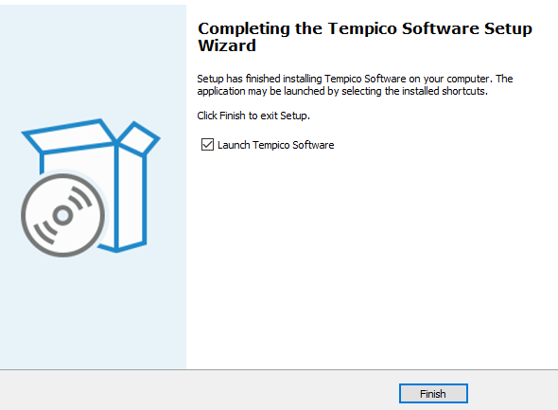

Ubuntu
On Ubuntu, you only need to download the compressed (.zip) file from the official page. Once downloaded, extract its contents and run the AppImage file found inside. With this process, Tempico Software will be ready to use on your system.
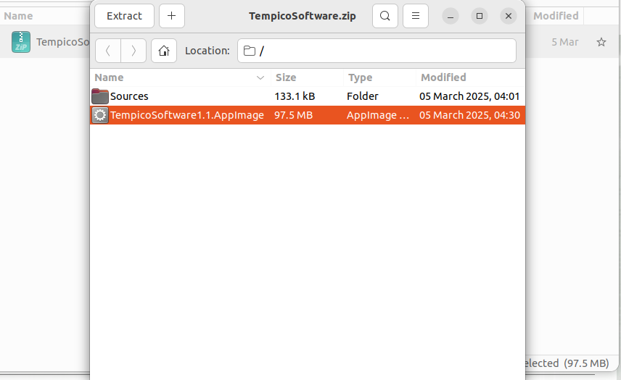
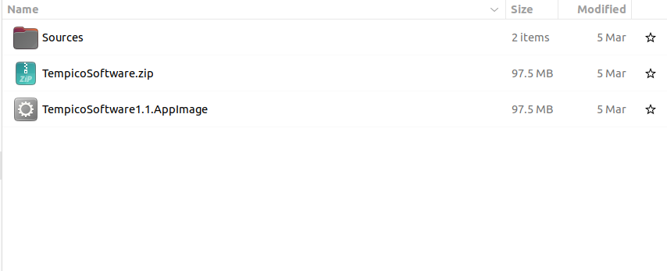

Mac
On macOS, you only need to download the .zip file and extract its contents to your preferred folder. The file named “Tempico Software” is the one you need to run to launch the program.
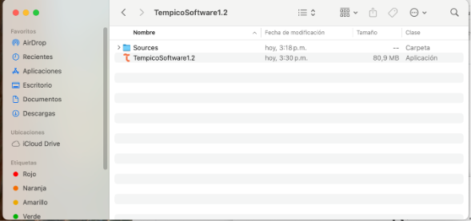

Software operation
The software is used in the same way across all operating systems; however, the preparations for running the software may differ depending on the operating system.

System configuration
To ensure the proper functioning of Tempico Software, it is necessary to perform certain validations on the operating system.

Windows
You should ensure that the Tempico device is recognized by the COM ports. To do this, follow these steps: If, when connecting and turning on the device for the first time, a window appears indicating that the Tempico device is being configured, it means that Windows has recognized it correctly. If this does not happen, you can access the Device Manager without having the device connected and navigate it to the COM and LPT ports section. Then, connect and turn on the device. The port table should be updated; if it does not, close and reopen the window. When doing so, a new COM device should appear, indicating that the Tempico has been correctly detected.

Ubuntu
ls /dev/tty*
In this case, it is also necessary to verify that the ports are correctly detecting the device. To do this, we will use the command above, which lists the devices connected to the serial ports. First, we will run this command without the Tempico device connected and then run it again with the device connected. We will observe which new device has been detected
sudo adduser "username" dialout
If an error occurs indicating that the serial port could not be opened, it is possible that the user does not belong to the dialout group. To resolve this, we will execute the command above. This will allow us to access the system's serial ports.
Si el comando no es suficiente y el software sigue lanzando errores debe verificarse cual es el puerto tty que se esta usando y debe ejecutarse lo siguiente:
sudo chmod 666 /dev/tty"port"

Mac
ls /dev/tty.*
To verify that the device is correctly connected to Mac, we must, with the Tempico turned off, execute the command above. This will provide a list of connected devices. Then, we run the command again with the Tempico turned on and observe which new port appears in the list.
If the device is not detected, the software will not recognize the connection, making it impossible to use the software. In this case, please contact Tausand support at: support@tausand.com.

Open the software and select a Tempico device
When opening the software, an image with the program's logo is displayed, followed by a window that allows you to select the device with the port to which you want to connect the device.

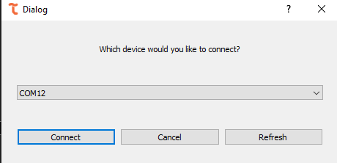
If the software is opened and the device is not turned on, the window will not recognize the connection. Therefore, it is necessary to click the "Refresh" button to update the list of ports with a Tempico device.
Once connected, the software will open with all options enabled for use. The software always opens in the histogram window.
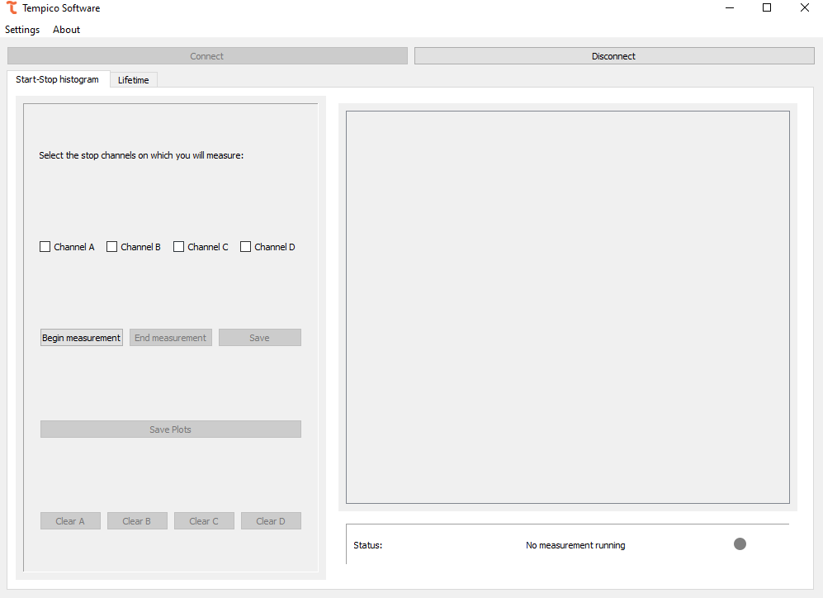
If "Cancel" is selected or the dialog box is closed, the options to select a channel or start a measurement will not be available.
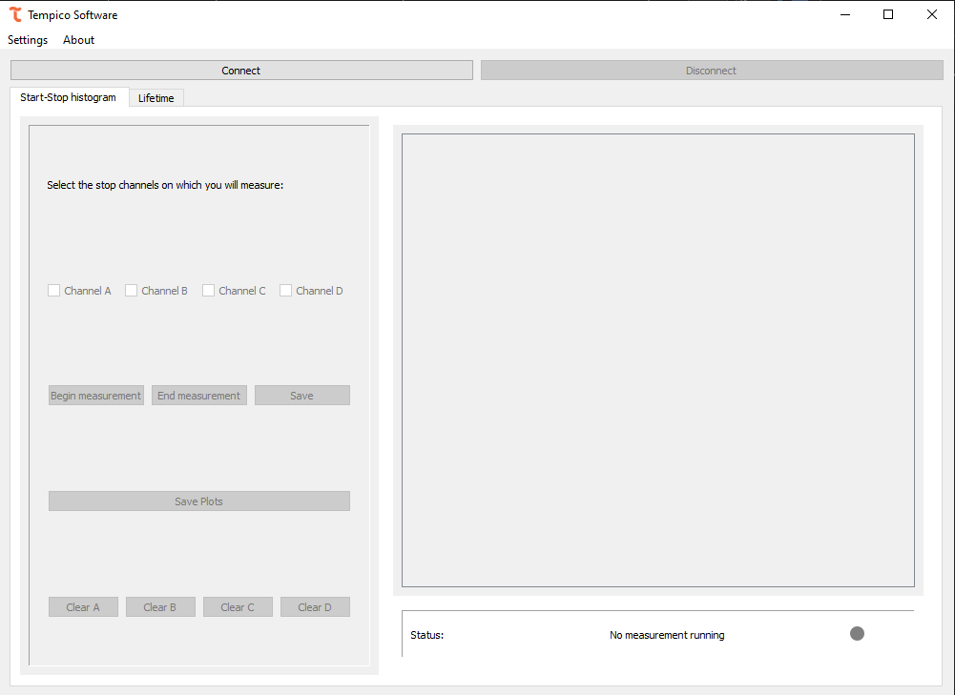
If this happens, we can click the "Connect" button again to search for devices.
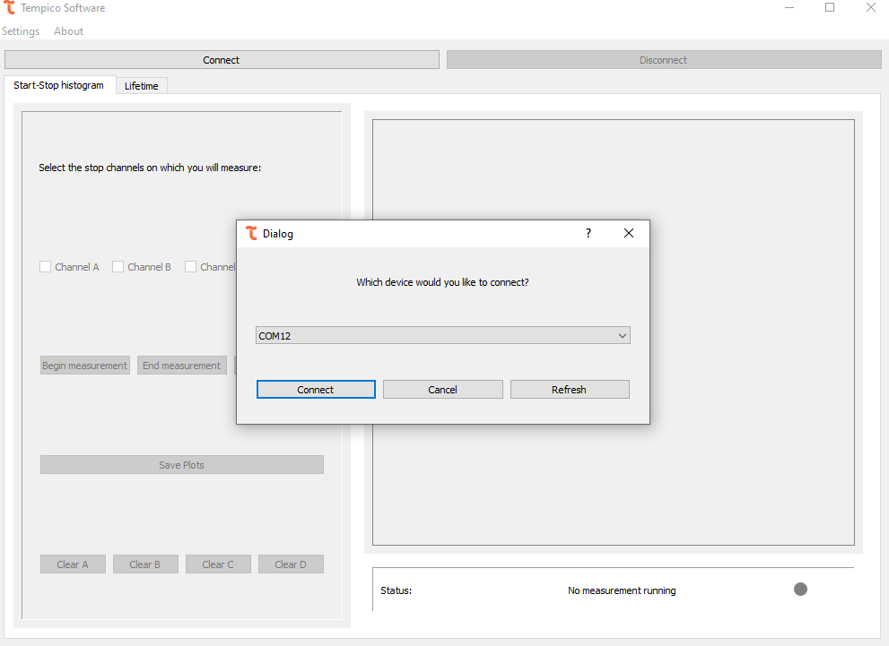

It is also possible to disconnect the device if we want to use another Tempico. To do so, click the "Disconnect" button. If an error occurs while connecting to the device, the following error window will be displayed:
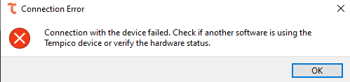
If this happens, it should be verified that no other program has established communication with the Tempico, and ensure that the USB connection, whether the cable or the physical port, is in good condition. If no issues are found after verifying this, support should be contacted to find a solution to the problem.

Channel settings
Once the connection with the device is established, it is possible to access the settings for each channel. To do so, go to the tab at the top, select "Settings," and then choose "Channel Settings," where you can view the current settings of the device:
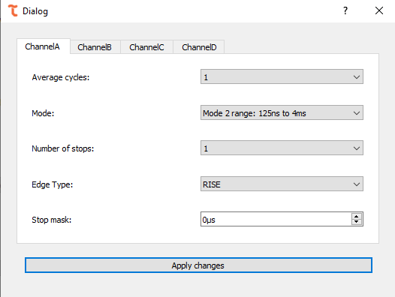
For each channel, you can modify the number of average cycles, the mode that defines the time range for measurements, the number of stops, the edge type and the stop mask. All these options provide a dropdown menu with the options allowed by the device (refer to the Tausand Tempico manual for more information), except for the stop mask.
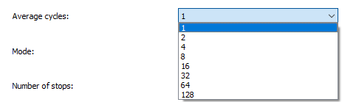
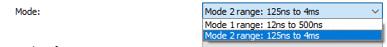
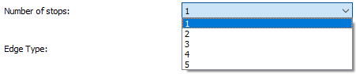
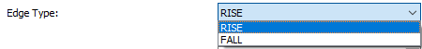
For the "Stop Mask," you can enter a number between 0 and 4000 µs.
Once the desired values have been changed, click the "Apply Changes" button to transmit the changes to the device. To verify the changes, you can return to the tab and check that the values are the same as those previously set.

General settings
The software features another window that displays the options affecting all channels of the device, including the start channel. To access it, go to the top, select "Settings," and then click on "General Settings":
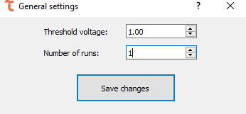
From there, it is possible to set the "Threshold Voltage" and the "Number of Runs" for the measurements. The "Threshold Voltage" value allows a range between 0.90 and 1.60, with increments of 0.01, while the "Number of Runs" allows up to a value of 1000 (for more information on these settings, refer to the device manual). Once the changes have been made, click on "Save Changes," and to confirm, return to the tab and check that the values are the same as those set.

TP1200 settings
The TP1200 versions from Tempico are equipped with an internal periodic pulse generator, which can be configured through the Tempico Software. To perform this configuration, the user must access the settings menu and select the Signal Generator option. In this section, it is possible to define whether the signals acquired by each channel originate from an external source, meaning a direct electrical connection to the device, by selecting “External”, or whether the signals originate from the internal pulse generator by selecting “Internal”.
Below the signal source selection for each channel, the pulse frequency of the internal generator can be adjusted. The available frequency range spans from 10 Hz to 9,450,000 Hz.
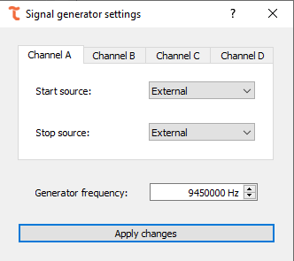

File path settings
In this dialog window, it is possible to modify the path where the data is stored, as well as the prefixes used to save the files from each tab. Each file is saved with the defined prefix followed by the date it was generated, ensuring an organized and easily traceable naming scheme. Within this window, three options are available: Apply Changes(), which updates the configuration according to the entered values; Cancel(), which closes the window without applying any changes; and Default Settings(), which restores the default values. It is important to note that this last option will not take effect immediately, since the values will only be applied once the user presses apply changes again.
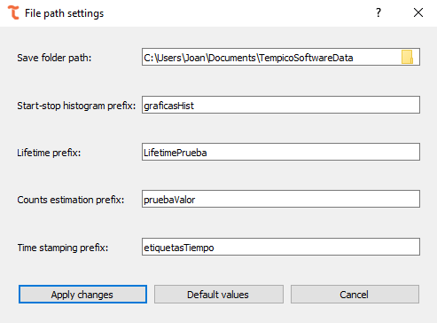

Start-stop histogram measurements
"Start-stop" measurements are those that capture data from the basic functionality of the Tempico device. When a start pulse is received and, subsequently, a stop pulse arrives, the temporal difference between the two pulses is obtained. This point is plotted on a frequency histogram.

Perform a measurement
To start the "start-stop" measurements, the channels to be sampled must be selected. To do so, check the corresponding checkboxes located on the left side of the window.
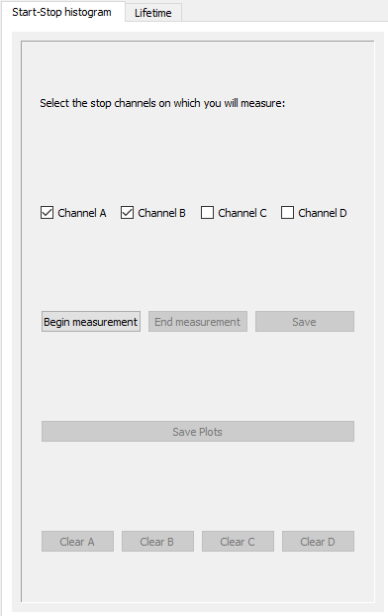
Afterward, click on "Begin Measurement" (). Depending on the number of channels selected, the corresponding graphs will be created on the right side of the window. Once the measurement begins, a histogram will be obtained for each channel.

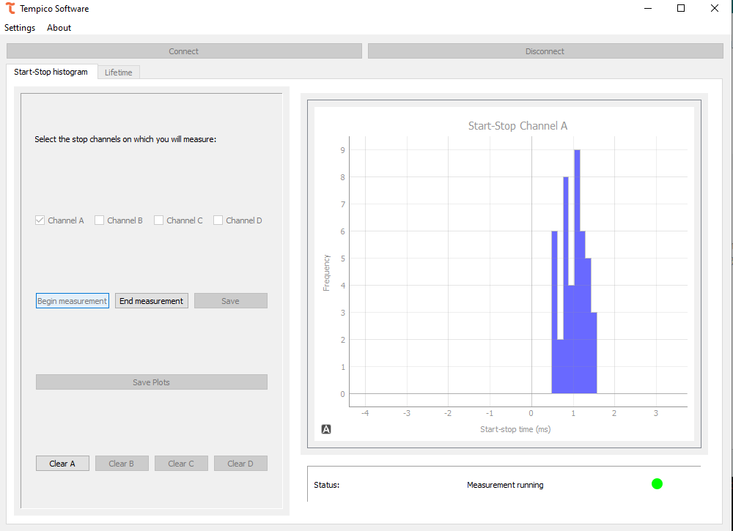
It is possible to interact with the graphs generated for each channel, either by dragging the range or adjusting the zoom with the mouse wheel. The histogram is generated according to the zoom level of the plot. Therefore, by zooming in and examining the range in more detail, more precise points will be obtained, indicating where each data point falls.
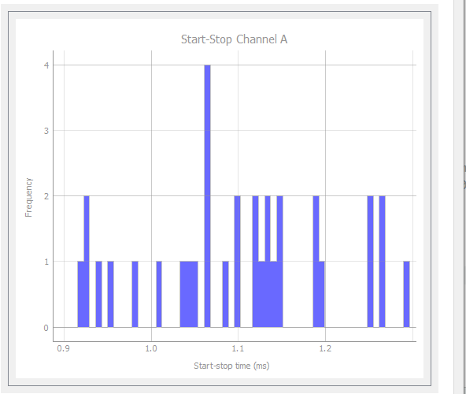

Conversely, if we increase the temporal axis range, the number of bars will decrease.
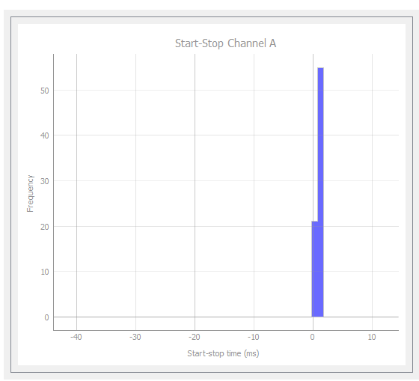
Right-clicking on the graph enables additional options for interacting with it, such as manual zoom on each axis, changing the selection mode with the mouse, or exporting the image. Since these options come from the library used to generate the graph, it is not recommended to interact with the graph through these functions. However, the user is free to use them if desired.
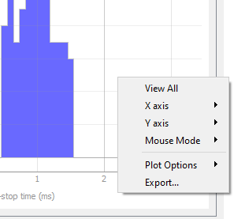
The status bar indicates whether the measurement is being carried out correctly. If any channel is not receiving data, the status bar will display a message to indicate this.
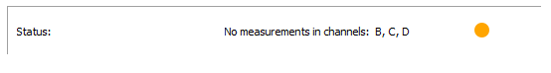
If the start channel is not receiving data, the following message will be displayed:
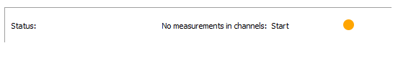
A possible solution to this issue is configuring the threshold voltage. It is recommended to set it to 1.6 V and check if the measurement is performed correctly. If the error persists, try different values for this parameter. If the issue continues and it is determined that it is not a fault in the setup or the input signal, Tausand support should be contacted.
Start-stop histograms are designed to take measurements indefinitely. Once the experiment is considered complete, click the "End Measurement" button ( ) to stop data collection. If you wish to clear the data during the experiment, there's no need to stop the measurement. At the bottom of the left menu, there are "Clear" buttons to erase both the data and current graphs. Four buttons are available to clear data for each channel independently ( , , , ).
For Tempico TP1200 versions, this window can measure negative ranges down to –200 ns. The purpose of this capability is to allow more accurate measurements of values close to zero, which in the TP1000 version are limited by its technical specifications.
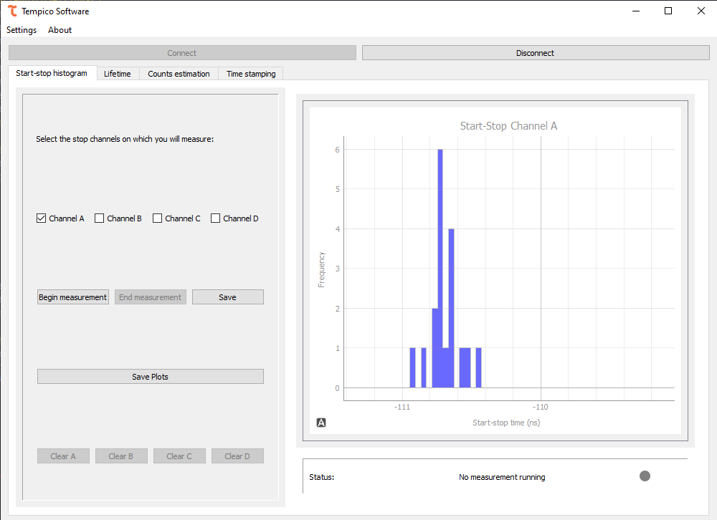

Save data and plots
If the user wishes to save the graphed data, they should click the save button ( ), which will open a menu allowing them to select the format in which to save the files.
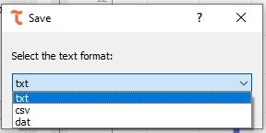
After selecting the desired format, click the accept button ( ), which will display a dialog box indicating that the file has been saved successfully
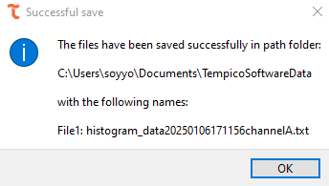
Files are saved in all operating systems in the "TempicoSoftwareData" folder within "Documents." By default, this folder is automatically created when the program is opened for the first time.
The data is saved in the same format. First, it includes the configuration applied when the data was collected, followed by the raw histogram information. This allows the user, if desired, to later manipulate the data according to their needs.
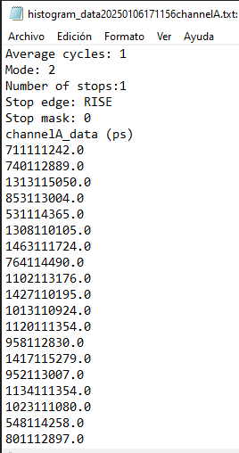
If the user wishes to save the graphs generated by the software during the measurement, they must click on the "Save Plots" button ( ). A window will then open, allowing them to select the image format.
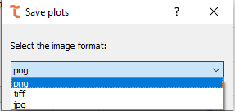
After selecting the format, click the "Accept" button ( ). As with the previous case, a dialog box will appear indicating that the image has been successfully saved. The image will be saved in the same location as the text files, across all operating systems.
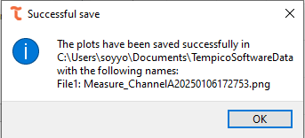
The saved image is the one displayed in the software at the moment of clicking "Accept." Therefore, the zoom applied to the graph will also be reflected when saving the image. If multiple channels are selected for measurement, the 4 images will be saved separately.
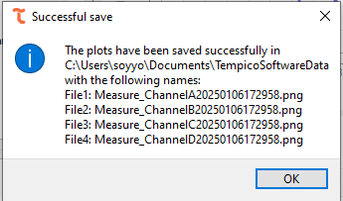

Lifetime histograms
To record lifetime measurements based on the time difference between input pulses and emitted excitation pulses, Tempico Software provides multiple tools to fulfill this functionality.

Settings before a measurement
Unlike the measurement of start and stop histograms, the preliminary setup for a lifetime measurement is a bit more elaborate. First, we must select the start channel and the stop channel for our measurements.
If a channel other than start is selected to initiate the measurement, a periodic electrical signal must be added to the start channel, as Tempico cannot measure signals on stop channels without a registered start event. This configuration risks losing data that arrives before the periodic signal is emitted. The pulse period must be short enough to reduce data loss. Tempico does not register stops occurring within less than 12 ns, making this setup useful for mitigating such effects.
After selecting the channel, the bin width must be chosen, representing the histogram's bar width. For example, with a bin width of 12 ns, if there are two measurements at 1 ns and 5 ns, both will contribute to the same histogram bar's frequency. The number of bins prevents histogram saturation and usually limits the time axis range. For instance, selecting a bin width of 480 ps and 50 bins results in a 24 ns range. Unlike start-stop histograms, lifetime measurements are designed with a limit, allowing the number of measurements to be specified. A measurement is counted when both start and stop channels record a value.

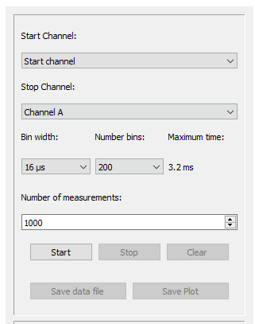
It's important to clarify that the configurations for the number of runs, number of stops, stop mask, and mode have no effect on this measurement. By default, the program sets the number of runs to 100, the number of stops to 1, the stop mask to 0, and the mode according to the maximum time parameter. If the maximum time exceeds 500 ns, the measurement operates in mode 2; otherwise, it operates in mode 1.

Perform a measurement
Once the desired configuration is selected, click the start button ( ) to begin the measurement. Like start-stop histograms, the program displays a status bar indicating the measurement's progress. If any channel is not recording, it will be shown. In this case, the percentage of the measurement is also displayed, as the number of desired measurements can be specified.

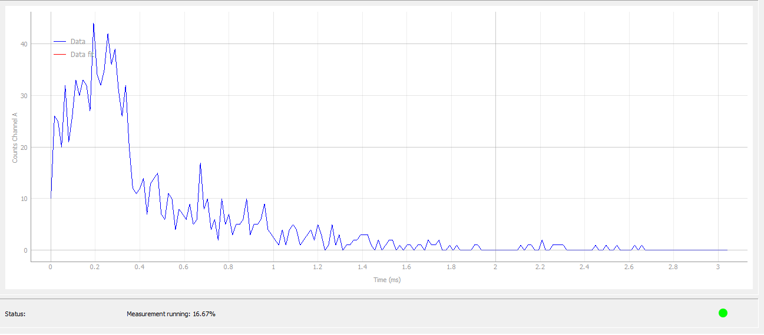

The program also provides additional information about the measurement status, including the total number of starts, the total number of complete measurements (i.e., start and stop), and the total elapsed time in HH:MM:SS format.
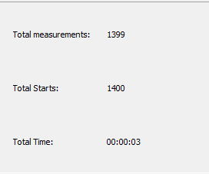

Fitting
Con el fin de obtener más información acerca de una medición, el usuario puede realizar un fit sobre la gráfica. Al realizar el fit obtiene en la tabla de la esquina superior derecha información más detallada acerca de los parametros de la ecuación a ajustar. Obtiene sus valores, su desviación estándar y sus respectivas unidades.

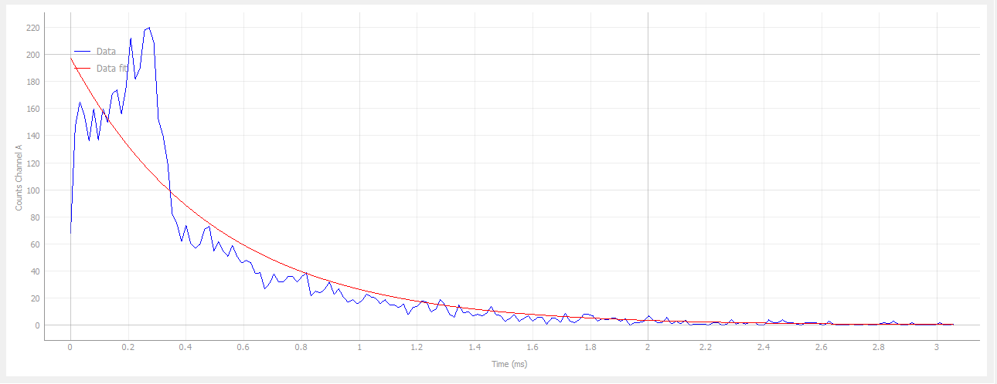

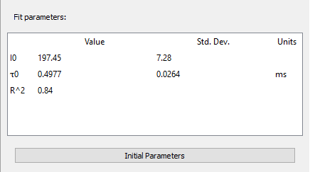
In some cases, reliable values may not be estimated, and the adjustment will indicate "nan" for those parameters. The quality of the fitness depends on the initial parameters set before the estimation. Therefore, users are free to modify these parameters. They can also revert to the default values provided by the software.
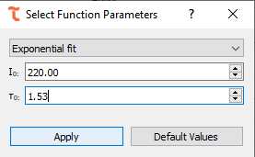

The software offers various types of adjustments:

Exponential
$$I_{0}e^{\frac{-τ}{τ_{0}}}$$
For fluorescence decay processes and certain radioactive processes, it is common to encounter exponential distribution. This distribution involves two parameters: by default, the initial value of $I_{0}$​ is set to the maximum found on the graph, and $τ_{0}$​ corresponds to the average of the measured times.

Shifted exponential
$$I_{0}e^{\frac{-τ+α}{τ_{0}}}+b$$
In some cases, an exponential distribution may exhibit a shift due to noise or inherent system characteristics. For these situations, an option for an exponential distribution with a shift is provided, allowing the user to correct the shift and obtain a pure exponential distribution. The initial parameters $I_{0}$​ and $τ_{0}$​ are the same as those used by default in the exponential distribution. However, the additional parameters $α$and $b$ are set to 0 by default.

Kohlrausch
$$I_{0}e^{{\left(\frac{-τ }{τ_{0}}\right)}^{β }}$$
In the case of fluorescence lifetime measurements, interactions may occur both in the environment and with the fluorescent material, which can be interpreted as noise in the final measurement. To obtain a profile that represents the dynamics of fluorescence, a Kohlrausch fit can be used. The default initial value for the $β$ parameter is 1.

Double exponential
$$I_{0}\left(α e^{\frac{-τ}{τ_{0} }}+\left(1-α\right)e^{\frac{-τ}{τ_{1} }}\right)$$
In some cases, the data may have more than one component, and the user may wish to separate the parameters of each. For these cases, a double exponential fit can be used. The default values are the same as those used in the exponential distribution; the default value for $α$ is 1, and the value for $τ_{1}$is the same as $τ_{0}$.

Save data and plots
Like the histogram functionality, the user has the option to save both the data and the image. If the user clicks the Save Data File button ( ), a window will appear to select the desired format for saving the data. The user can choose between txt, csv, or dat formats.
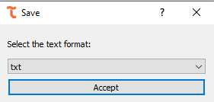
If the user clicks the Accept button ( ), a window will appear confirming that the file has been successfully saved and displaying the path where it was stored.
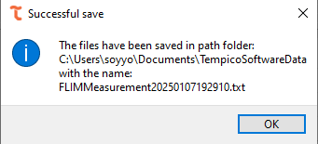

If the user clicks Save Plot ( ), they can choose from three formats: PNG, TIFF, and JPG. Upon clicking the Accept button, a window will confirm that the file has been successfully saved and display the path where it was stored.
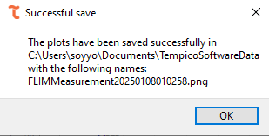
If an adjustment is applied, both the image and the text data will include the equation of the adjustment made, along with the calculated parameters.
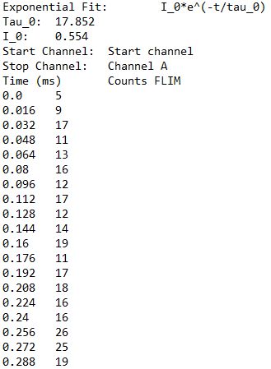
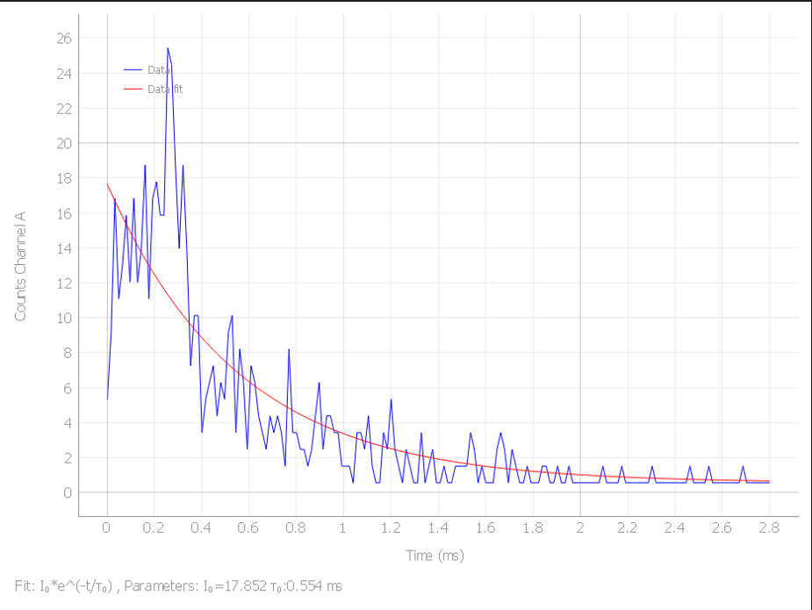

Counts estimation
Tempico Software does not directly provide the exact count of pulses received on each channel, since the Tempico device accepts a maximum of five incoming pulses after a start pulse. However, the software offers a feature that enables reliable count estimation by analyzing the time intervals between pulses.

Settings for signal measurement
To estimate pulse counts in Tempico Software, it is essential that the measurement includes a periodic start pulse of very short duration, and that the source to be measured is connected to one of the available channels (A, B, C, or D). In this process, software settings such as average cycles, mode, number of stops, and stop mask have no effect, as the system automatically configures these parameters during the measurement. The software calculates the average time differences between the pulses detected on the active channel, then computes the inverse of this value to determine the pulse frequency per unit of time, and finally converts the result into seconds, obtaining an estimate of the number of pulses per second. A graph is shown below to illustrate a representative signal used for this type of estimation.
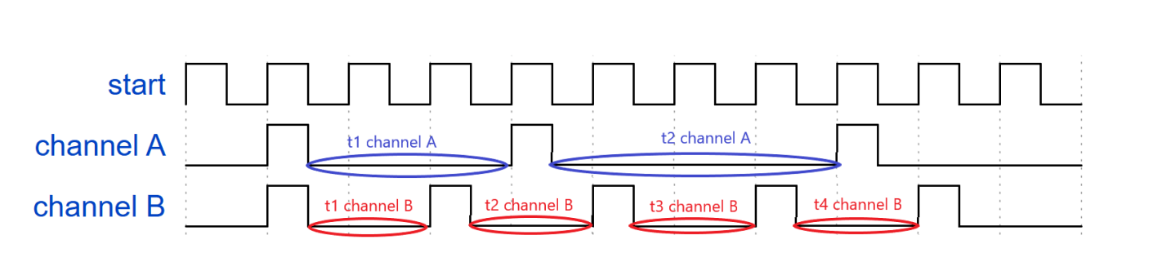
The signal clearly shows the periodic start pulse that must be emitted, along with two sets of pulse measurements recorded on Channel A (blue) and Channel B (red), respectively. For Channel A, the software identifies the times t1 Channel A and t2 Channel A. To obtain t1, it subtracts the timestamp of pulse 1 from pulse 2, and for t2, it subtracts pulse 2 from pulse 3. Then, the software calculates the average between these two values, obtains their inverse, and converts the result into seconds. For Channel B, the same procedure is followed: the average is calculated between t1 Channel B, t2 Channel B, t3 Channel B, and t4 Channel B, then the inverse is obtained, and the result is converted to seconds. This final value is reported as the measurement result.
The Tempico device has a 4-millisecond window to receive a stop pulse after a start pulse is received. Additionally, it is essential that at least two pulses are detected after the start pulse during the measurement process, as otherwise it will not be possible to calculate the time differences between pulses. Therefore, the input signal must have a minimum frequency of 500 pulses per second for the software to accurately estimate the counts.

Settings before measurement
For this functionality, users can configure the channels on which the count estimation will be performed, as well as choose from different types of graphical displays. The merge option overlays the curves of all channels on a single graph; separated creates an individual graph for each channel; and detached opens each graph in a separate, resizable dialog window. Additionally, the detached table option displays the temporal count history in an independent dialog. The time range parameter allows users to define the time intervals over which the measurement graph will be displayed.
It is important to note that not all settings become locked once the measurement begins. The only configuration that becomes restricted is channel selection, which prevents enabling channels that were not selected prior to starting the measurement. All other settings can be adjusted dynamically while the measurement is running. The following figure shows the configuration panel for these options.
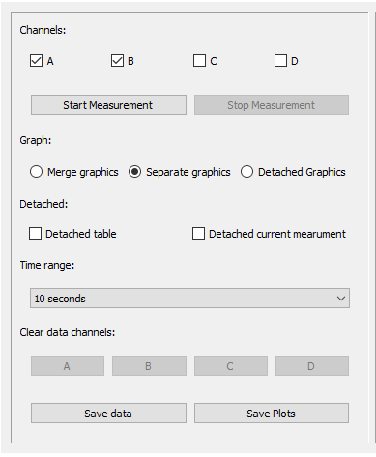
Once the user starts the measurement, the system automatically determines the number of stops required to begin count estimation. This step is critical, as configuring the Tempico device with several stops greater than the actual number of pulses received after a start pulse would result in no valid measurements being detected. To prevent this issue, the software analyzes the incoming signal behavior and automatically adjusts the appropriate number of stops before starting the counting process.
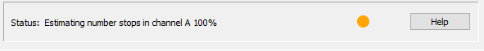
If the software detects that a channel is unable to register more than 2 stops, it will notify the user and prompt whether to stop the measurement or continue with the remaining active channels. This mechanism ensures user control over the process and helps prevent unreliable results from channels with insufficient signal.
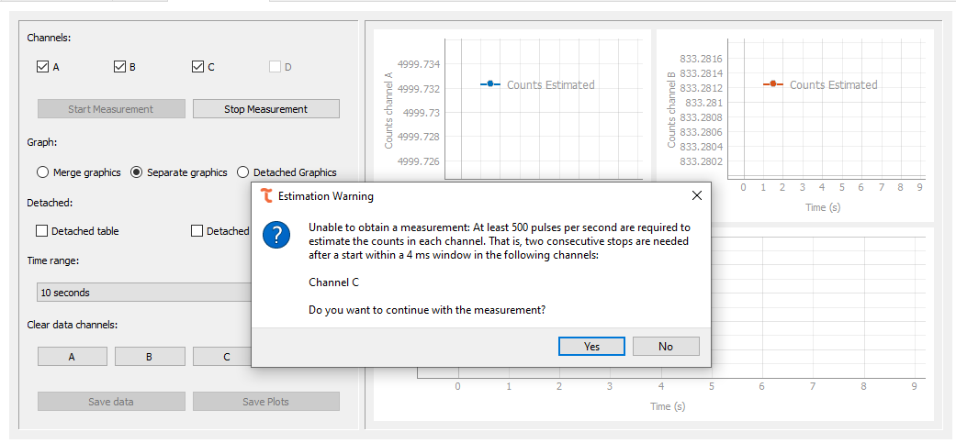

If the user chooses to continue the measurement, the channel for which no valid data was found will be automatically disabled and cannot be reselected unless the current measurement is stopped and a new one is started. This ensures that only channels with valid signals are considered during the estimation process.
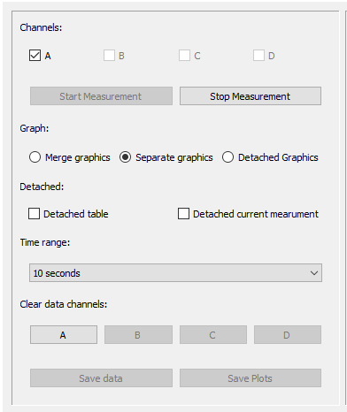

If the user chooses not to continue, the software will automatically terminate the measurement, ensuring that no channels without valid signals are processed.

Perform a measurement
To start the measurement, you must click the Start Measurement ( ) button, which will begin the stop number estimation process described earlier. Once this process is complete, the measurement will begin to run correctly.
First, we have the graphical section; if the Merge Graphics ( ) option is selected, all curves from the selected channels will be displayed in a single chart.
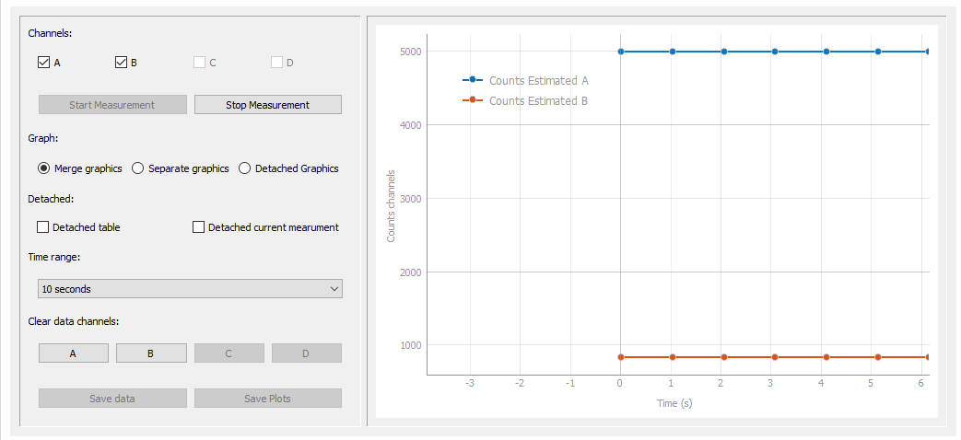
Whereas if the Separate Graphics (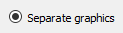 ) option is selected, the curves for each channel will be displayed individually, each in its own separate chart.

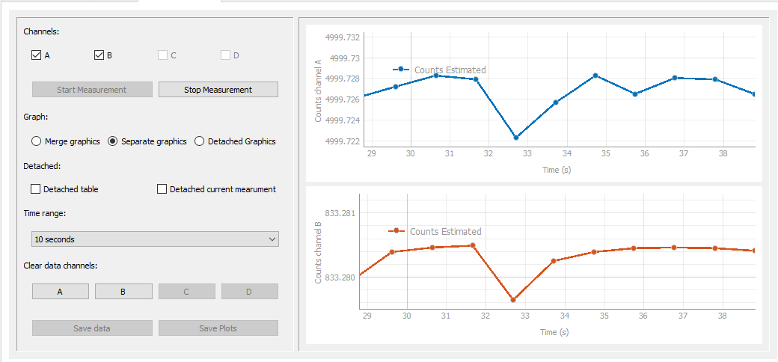
We also have the Detached Graphics (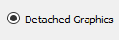 ) option, which displays the graphs in separate dialog windows that open independently from the main window.
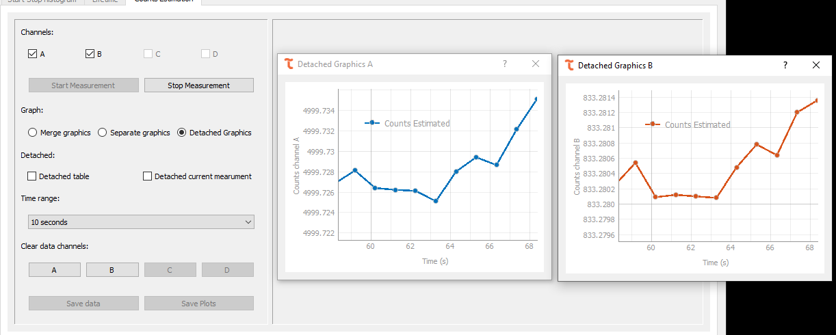
Time filters can be applied to the graphs using the Time Range dropdown menu. This allows you to adjust the time range on the X-axis to view the measurement history in detail. For example, if you select 50 seconds, all graphs will display the last 50 seconds of the recorded data.
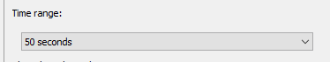
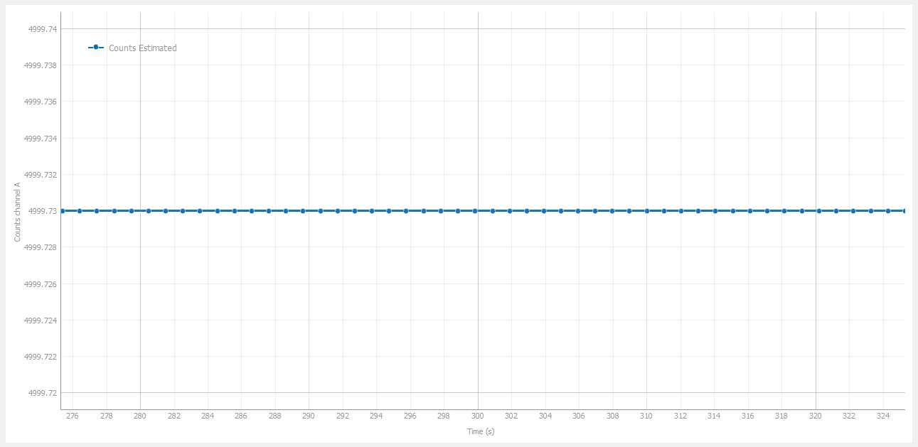
During the measurement, there is also a table section that displays the history of the estimated count values along with the corresponding hour, minutes, and seconds of registration. This section is located below the graphs displayed on the screen.
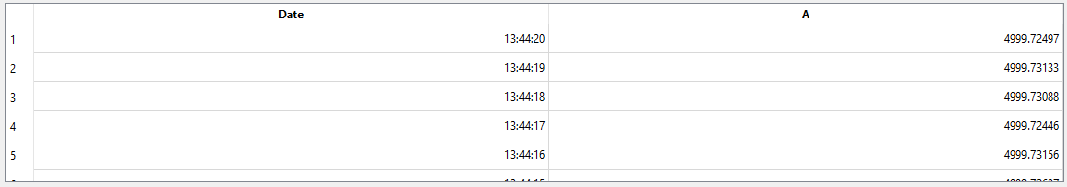
If the user wants to view the table more clearly, they can enable the detached table option available in the settings panel. This will display the table in a separate dialog window, showing the same data as the one at the bottom of the main window, but with enhanced detail.
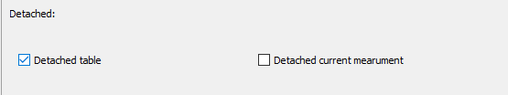
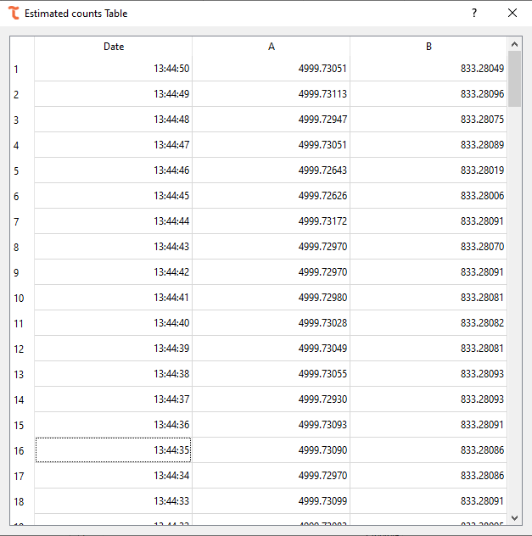
Likewise, in the bottom-left corner of the main window, the user can view the value and the uncertainty corresponding to the most recently reported measurement.
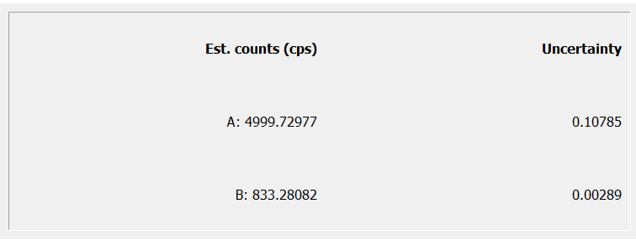
As before, the user can choose to view the current values in detached mode by clicking the corresponding checkbox.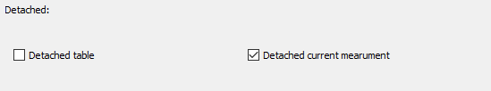

After that, a separate dialog will open displaying the current measurement values.
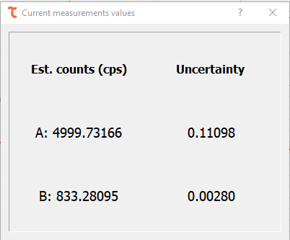
If a channel stops emitting values during the measurement process, the software will notify the user through the status bar. Additionally, the results table will display the message Low Counts, indicating that the device is unable to perform the measurement because the number of received counts is insufficient.
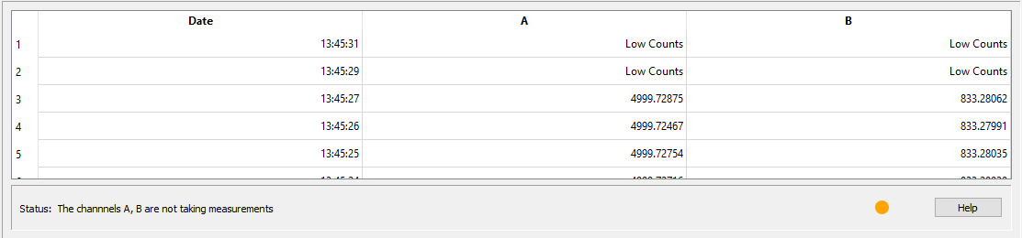
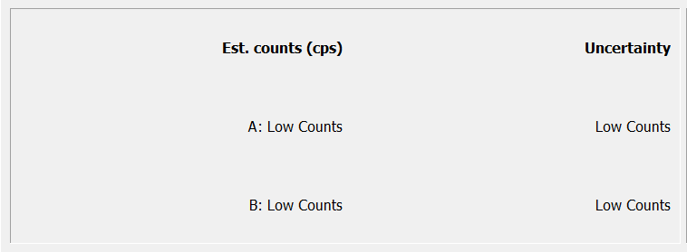
Once measurements are registered again on the channel, the process will resume normally.

Save data
The user is responsible for deciding when to stop the measurement. To do this, they must click the Stop Measurement ( ) button. After this, the Save Data ( ) button will be enabled, allowing the user to save the data in plain text format. Upon clicking this button, a window like those used in other functionalities will appear, prompting the user to choose the format in which they wish to save the measurement.
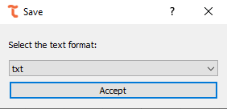
Among the available formats for saving the data are .txt, .csv, and .dat. Upon clicking Accept, a window will appear confirming that the values have been successfully saved and displaying the path where the files are located.
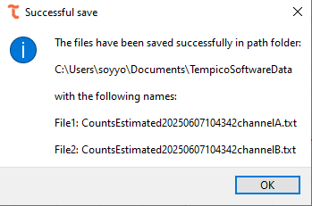
The file will store both the timestamp of the recorded data and the corresponding estimated count value.
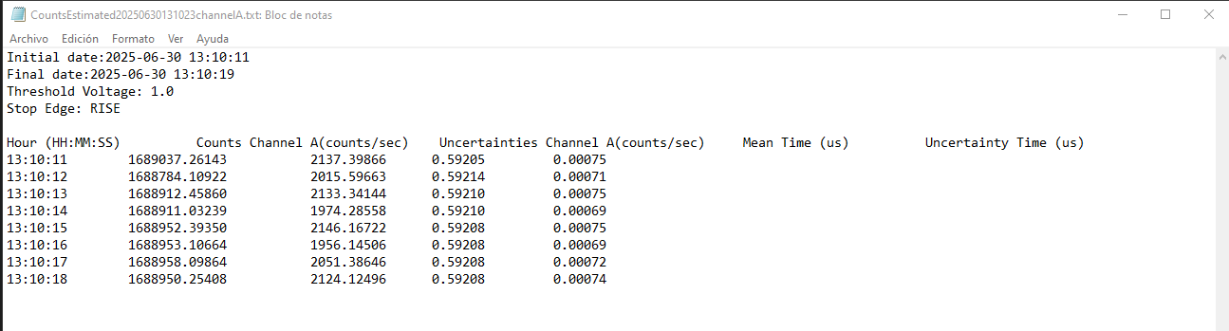

Save plot
Similarly, once the measurement is completed, the option to save the plots () will be enabled. As in the previous sections, a window will appear allowing the user to select the format in which they wish to save the graph, including PNG, TIFF, and JPG.
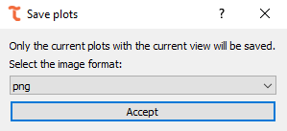
After clicking the accept button, a dialog window will open indicating the path where the image was saved, including the file name and selected format.
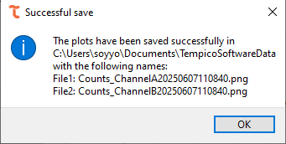
The graph will be saved exactly as it appears on screen. If the time range filter has been applied, the image will reflect the corresponding values on the X-axis. Additionally, if the graph has been visually adjusted—either stretched or displayed with specific width-to-height proportions—those proportions will be preserved when the graph is saved.
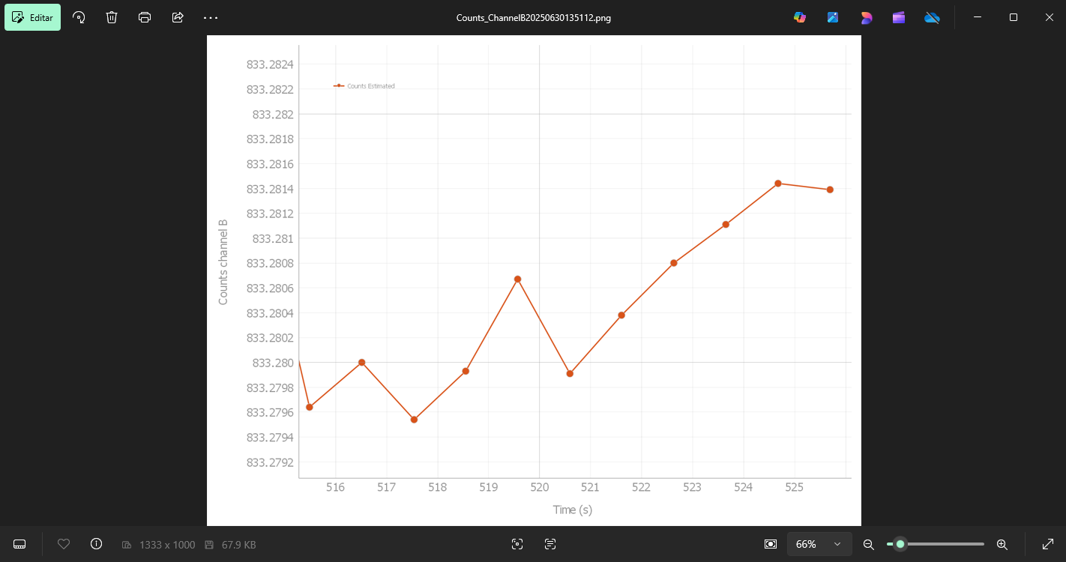

Time stamping
To comprehensively capture every pulse arriving at the start channel, together with its corresponding stop pulses, while recording the precise timestamp of each event, Tempico Software provides a measurement mode optimized for fast and efficient data acquisition. This mode is specifically designed to handle large data volumes.

Settings before measurements
As with start-stop histogram measurements, any adjustment made in this tab—whether through global settings or channel-specific configurations—directly affects the measurement.
Before starting a measurement, users can select the channels on which data will be recorded—options include channels A, B, C, or D.
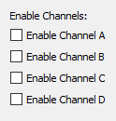
Users can also choose whether to display the measurement results table, which may help reduce resource consumption. Furthermore, this option can be enabled or disabled even after the measurement has already started.

Manual measurement
For this type of measurement, no prior parameters need to be configured; the user simply clicks the Start Measurement button.
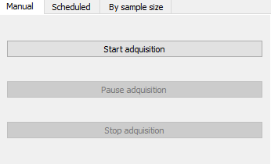

Scheduled measurement
In this mode, the user specifies both the start time and the stop time of the measurement. These values must be consistent with the system’s date and time settings. For instance, if a start date and time are set in the past when the measurement begins, the program will display an alert requesting the user to adjust the values. Similarly, if the stop time is set earlier than the start time, a similar alert will be generated.
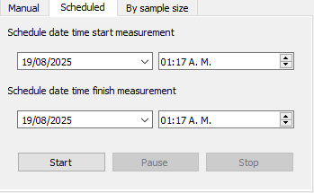

By sample size measurement
In this case, the user must define the number of measurements to be recorded. Once this number is reached, data acquisition will automatically stop.
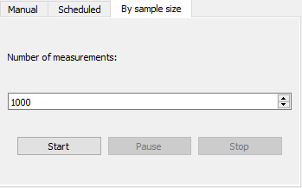
Note: If a start pulse is received without a corresponding stop pulse, the software will still log it as a valid measurement and include it in the dataset.

Autosaving measurements
The tab dedicated to handling large data volumes includes an autosave feature, designed to prevent data loss in the event of system failures or hardware limitations. This functionality allows data to be stored automatically at user-defined intervals, as well as at the end of each measurement.
The autosave interval can be freely configured. However, during the saving process, acquisition is briefly paused (typically a few seconds for short intervals, depending on the hardware). The available time intervals are shown in the corresponding figure.
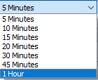
If an unexpected error occurs—such as an operating system failure, hardware malfunction, or sudden shutdown/restart—data can be recovered from the installation root directory of Tempico Software, inside the TempData folder. This directory contains the file AutoSaveData.txt, which stores all data recorded up to the last autosave. Although it is not recommended to open this file directly, it can be used as a recovery resource if necessary.
If autosave is disabled, users must manually click the Save Data button at the end of the measurement to preserve results. This approach is recommended for short acquisitions where every recorded value is critical.
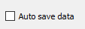
Technical considerations:
When data is not immediately saved, it is temporarily stored in RAM. In the 32-bit version of the software, memory usage is limited to 4 GB per process, regardless of the system’s available resources. In the 64-bit version, the program can access all installed memory. It is strongly recommended to keep autosave enabled, as the software can acquire more than 2000 data points per second. For reference, storing 22 million data points in RAM requires approximately 4 GB of memory.

Perform a measurement
Once the desired configuration has been completed, the measurement can be started by pressing any of the start buttons corresponding to the selected tab (,).
If autosave is enabled, a window will pop up asking the user to select the format in which the data should be saved.
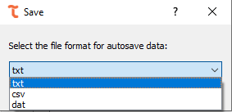
After confirming the format () in case autosave is enabled, or simply by pressing start if it is not, the measurement will begin. The only exception is the scheduled measurement, where a countdown will appear indicating the remaining time before the measurement starts.
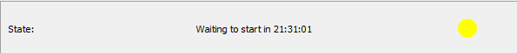
When this countdown is active, it is as if the software were already running the measurement, since it is not possible to change the tab or device configurations. If the user wishes to cancel the process before it begins, they may do so by pressing the stop button ().
Once started, the table will begin recording values. Start pulses will be stored with year, month, day, hour, minute, and second format, with microsecond resolution. Stop pulses will be stored with picosecond resolution, along with the channel information that generated them, the table will show only the last 50000 start stop and channel values.
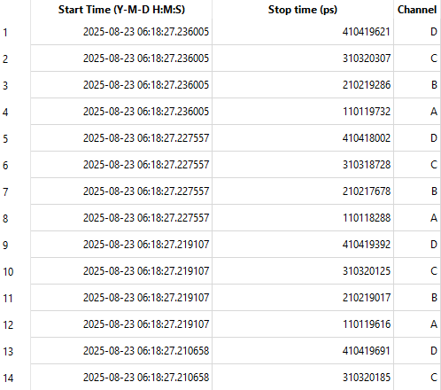
For the Tempico TP1200 versions, it is possible to obtain negative measurements with a range of down to –200 ns.
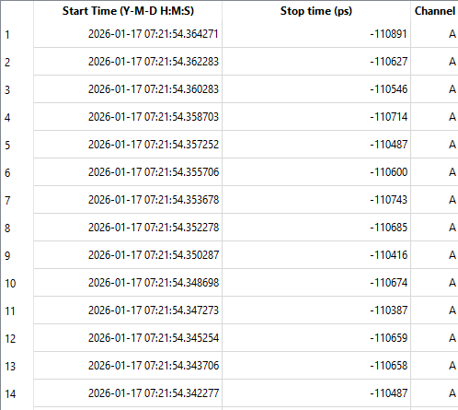
The panel in the lower-left corner will display the total number of measurements recorded per channel, as well as the overall total.

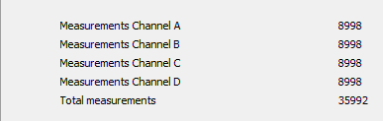
The status bar will indicate whether the measurement is running correctly or if there is an issue with the selected channels.
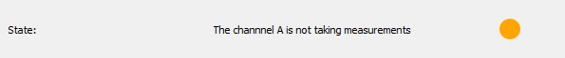
It will also show progress depending on the measurement type. For scheduled measurements, the status bar will display the remaining time until completion.
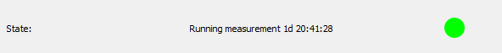
For sample-size-based measurements, it will show the progress percentage according to the number of acquired records compared to the expected amount.
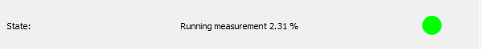
When autosave is in process, the status bar will display the message saving data. The duration of this message corresponds to the time during which the software pauses acquisition to save the accumulated data.
The measurement can also be paused by clicking the Pause (,) button. This option allows the user to temporarily stop the measurement without starting a new one or losing the data already recorded. It is particularly useful when a connection needs to be adjusted in the timer without restarting the entire process.
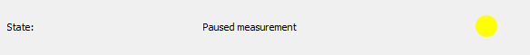

At the end of the measurement, the status bar will indicate that the data is being processed. During this step, the information is saved in the path selected by the user and the records are organized.
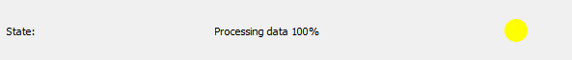
In any type of measurement, it is possible to manually stop the process at any time by pressing the stop button (, ).
If autosave was enabled, at the end of the process a window will pop up confirming that the measurement was successfully saved and showing the path where the file was stored.
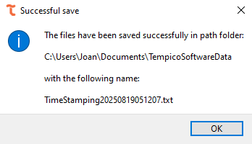

Save data
For the time stamping functionality, the user can only save the data generated by the software. This process begins when clicking on the Save Data button, which is only enabled if the Auto Save checkbox is not selected. Once pressed, a dialog window appears, allowing the user to choose the file extension with its corresponding format. The available options are .txt, .csv, or .dat.
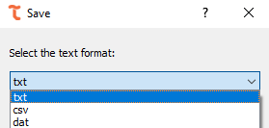
If the user previously had the Auto Save option enabled and attempts to save the data again using the same format initially selected, the software will display an alert notifying that the data has already been saved.

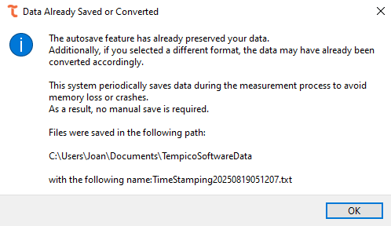

If the user chooses a different file extension, the data will be saved again, but this time in the new format specified in the dialog window.
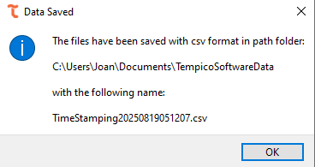
When the Auto Save option is not enabled, the software displays an additional dialog window indicating the percentage of progress during the data processing stage.
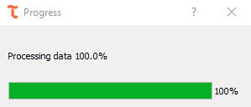
At this point, the data is sorted and subsequently saved in the desired path defined by the user. Finally, once the operation is completed, a confirmation dialog—similar to the one shown previously—appears to indicate that the data has been successfully stored.
The file that stores the data within the header includes the configurations applied to each channel at the time the measurement was performed. This file is organized into three columns: the first corresponds to the start value, represented in the format year-month-day-hour-minutes-seconds; the second contains the stop value, which is expressed in picoseconds; and the third identifies the channel in which the measurement was recorded. In this way, the information is structured and linked both to the temporal start point and to the corresponding channel.
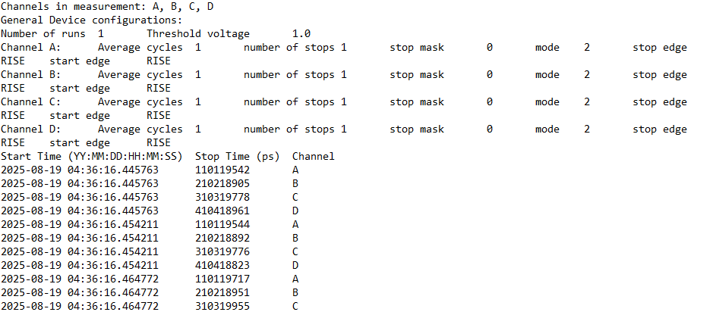

Autocorrelation (Fluorescence Correlation Spectroscopy)
The Autocorrelation (FCS) tab allows the user to compute the normalized intensity autocorrelation function G(τ) from the stop timestamps recorded on a single channel, which is the basis of Fluorescence Correlation Spectroscopy (FCS) experiments. From the shape of this curve, parameters such as the diffusion time, the number of particles in the observation volume or the presence of chemical or triplet-state dynamics can be estimated through curve fitting.

Settings before measurements

The input signal connected to the stop channel must satisfy a minimum requirement: at least 2 stop pulses per start cycle must be received. This is because the software discards the first stop of every cycle, using it only as a time reference, and computes the actual inter-photon intervals from the second stop onward; if fewer than 2 valid stops are received in a cycle, that cycle contributes no data to the correlation curve.
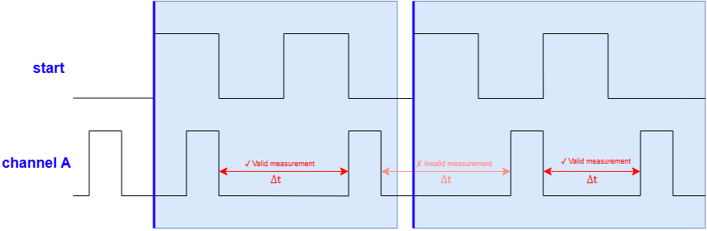
Regarding the acquisition settings, the user must configure the following correlator parameters, located on the left panel of the tab. The Stop Channel dropdown selects the channel (A, B, C, or D) whose timestamps will be correlated. The Base bin width τ₀ field sets, in microseconds, the shortest lag time of the multiple-tau correlator, and can be figured from 1 µs up to 10,000,000 µs; this value should be chosen according to the expected diffusion or relaxation times of the sample, since a base bin width that is too large may not resolve fast dynamics, while one that is too small may unnecessarily increase the noise at short lag times. Finally, the user can either set a fixed Duration, from 1 second up to 24 hours, or enable the Continuous measurement checkbox, which ignores the duration value and keeps the correlation running until the user presses Stop.
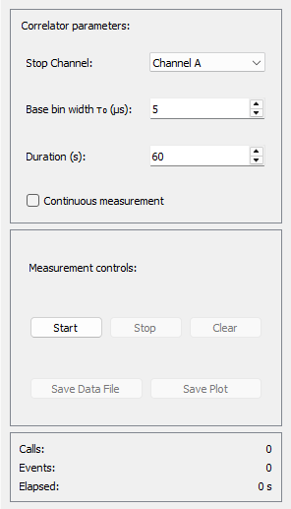

Perform a measurement
Once the desired configuration is selected, click the Start button to begin the acquisition. While the measurement is running, the Stop Channel, the Base bin width τ₀, the Duration, and the Continuous measurement option are locked and cannot changed. The autocorrelation curve G(τ) is plotted live against τ on a logarithmic time axis as new data arrives. At any point the user can press Clear to reset the curve, or Stop to end the measurement before the configured duration elapses.
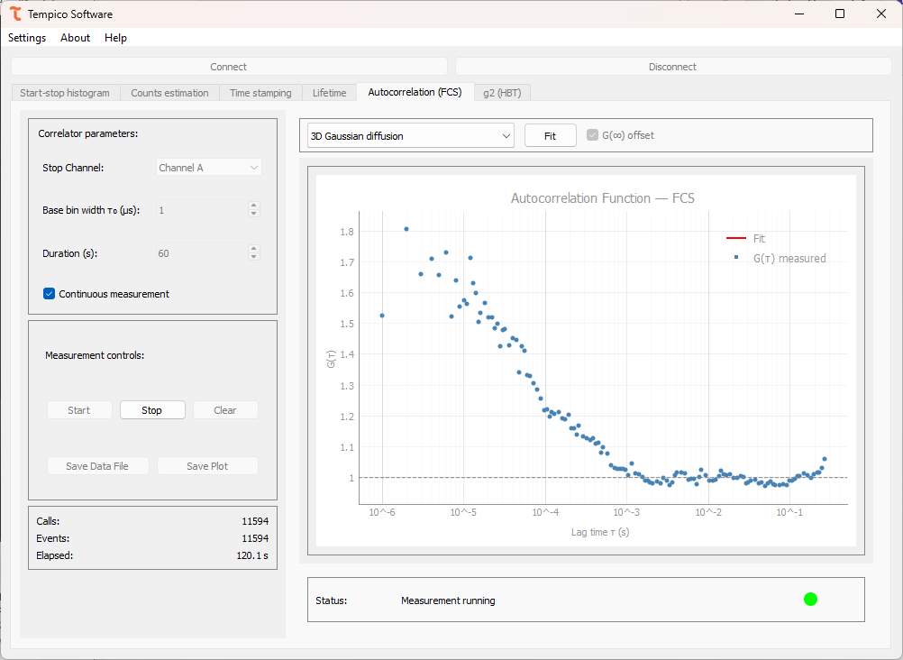
The panel below settings reports the acquisition progress through three values: Calls, which indicates the number of calls made to the device since the measurement started; Events, which indicates the number of valid stop events detected on the selected channel since the measurement started; and Elapsed, which indicates the elapsed time since the measurement started, shown in seconds and, if applicable, against the total configuration duration.
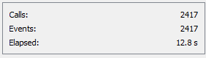
Next to this panel, the Status bar shows a colored dot together with a short descriptive message, which the user should monitor throughout the measurement. A grey dot indicates that no measurement is currently running. A green dot indicates that the measurement is running normally, with the message reporting the current number of calls, events and elapsed time. An orange dot indicates that a warning condition was detected; the message “No measurements in Start Channel” means that the device is not receiving any start pulses, while the message “No measurements in Stop Channel [A/B/C/D]” means that no valid pulses are being detected on the selected stop channel. If either warning persists, the user should check the corresponding cable connections and the signal levels before continuing the measurement.

Post-measurement

Fitting
Once the measurement finishes, the user can fit the measured curve to one of six correlation models available in the fit model dropdown, located in the upper-right panel. Selecting a model updates the equation shown above the parameter table, which list an editable Initial value column and a read-only Fit result column. The Auto button restores the initial guesses automatically suggested by the software for the selected model, and the G(∞) offset checkbox adds a constant baseline term to the fitted equation of any model.
Clicking Fit runs the fit and fills the Fit result column; the fitting curve is the overlaid on the plot, distinguished by the Fit and G(τ) measured legend entries. If a reliable value cannot be estimated, the software reports “nan” for the parameter. Since the quality of the fit depends on the initial guesses, the user is free to edit them manually in the Initial value column before running the fit again, or restore the software’s suggested values with the Auto button.
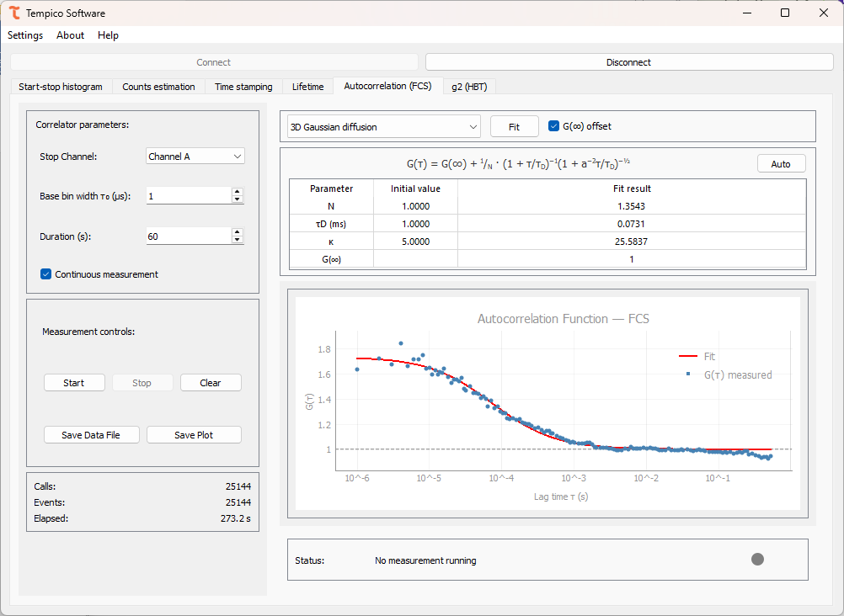

Gaussian diffusion
$$G\left(∞\right)+\frac{1}{N}∙{\left(1+\frac{τ}{τ_{0}}\right)}^{-1}∙{\left(1+a^{-2}\frac{τ}{τ_{0}}\right)}^{-\frac{1}{2}}$$
Describes a singles species diffusing freely in three dimensions through a Gaussian observation volume, The fitted parameters are N, the average number of particles in the observation volume.

Anomalous diffusion
$$G\left(∞\right)+\frac{1}{N}∙{\left(1+{\left(\frac{τ}{τ_{D}}\right)}^{a}\right)}^{-1}∙{\left(1+a^{-2}{\left(\frac{τ}{τ_{D}}\right)}^{a}\right)}^{-\frac{1}{2}}$$
Extends the 3D Gaussian diffusion model to account for non-Brownian, anomalous transport. In addition to N, τ_{D} (ms), and κ, it includes the anomaly exponent α which equals 1 for normal diffusion and deviates from 1 when the diffusion is sub- or super-diffusive.

Chemical relaxation
$$G\left(∞\right)+\frac{1}{N}∙K∙\exp\left[-\frac{τ}{τ_{B}}\right] \left[G\left(0\right)=\frac{K}{N}, K=\frac{k_{on}}{k_{off}}\right]$$
Describes a two-state chemical equilibrium, such as binding/unbinding or blinking, rather than diffusion. The fitted parameters are N, the relaxation time τ_{B}, in ms, and K, the ratio between the on- and off-rate constants of the reaction (K = k_{on}/k_{off}).

Diffusion with flow
$$G\left(∞\right)+\frac{1}{N}∙{\left(1+\frac{τ}{τ_{D}}\right)}^{-1}∙{\left(1+a^{-2}\frac{τ}{τ_{D}}\right)}^{-\frac{1}{2}}∙\exp\left[-\frac{{\left(\frac{τ}{τ_{v}}\right)}^{2}}{1+\frac{τ}{τ_{D}}}\right]$$
Combines 3D Gaussian diffusion with a directional flow term, useful when the sample is subject to a net drift, such as in a microfluidic channel. The fitted parameters are N, τ_{D} (ms). The structure parameter a, and the flow time τ_{v}, in ms, which represents the average transit time of a particle across the observation volume due to flow.

Triplet state correction
$$G\left(∞\right)+\frac{1}{N}∙\frac{1-F+F∙\exp\left[-\frac{τ}{τ_{F}}\right]}{1-F}∙{\left(1+\frac{τ}{τ_{D}}\right)}^{-1}∙{\left(1+a^{-2}\frac{τ}{τ_{D}}\right)}^{-\frac{1}{2}}$$
Adds a photophysical blinking term to the 3D Gaussian diffusion model, accounting for fluorophores transiently entering a non-fluorescent triplet state. The fitted parameters are N, τ_{D} (ms), the structure parameter a, the triplet fraction F, which represents the proportion of molecules in the triplet state, and the triplet relaxation time τ_{F}, in µs.

Two-component diffusion
$G\left(∞\right)+\frac{1}{N}∙\left({a_{1}∙\left(1+\frac{τ}{τ_{D1}}\right)}^{-1}∙{\left(1+a^{-2}\frac{τ}{τ_{D1}}\right)}^{-\frac{1}{2}}+{a_{2}∙\left(1+\frac{τ}{τ_{D2}}\right)}^{-1}∙{\left(1+a^{-2}\frac{τ}{τ_{D2}}\right)}^{-\frac{1}{2}}\right)$
Models two diffusing species with different mobilities, such as free dye and dye bound to a larger complex. The fitted parameters are N, the diffusion times of each species τ_{D1} and τ_{D2}, in ms, the amplitude fraction of the first species α₁, and the structure parameter a.

Save data
Once the measurement finishes, the Save Data File button is enabled. Clicking it opens a dialog window where the user selects the file format: .txt, .csv, or .dat. Two files are generated: one containing the τ/G(τ) pairs of the autocorrelation curve, and another with the measurement window, the device model, the correlator parameters, and the selected stop channel; if a fit was performed, the fit model, its equation, and the resulting parameters values are also included in the leader.
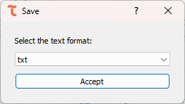

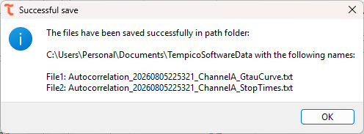
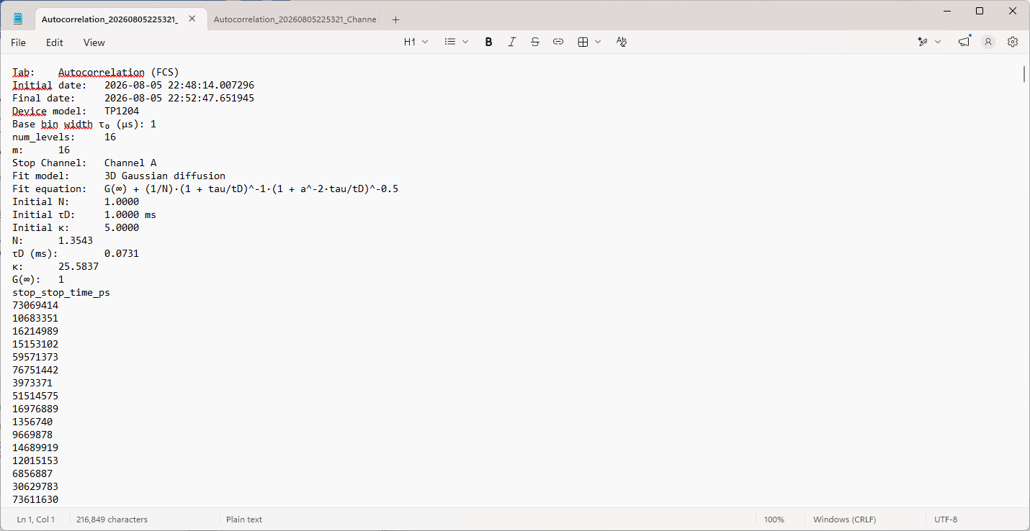

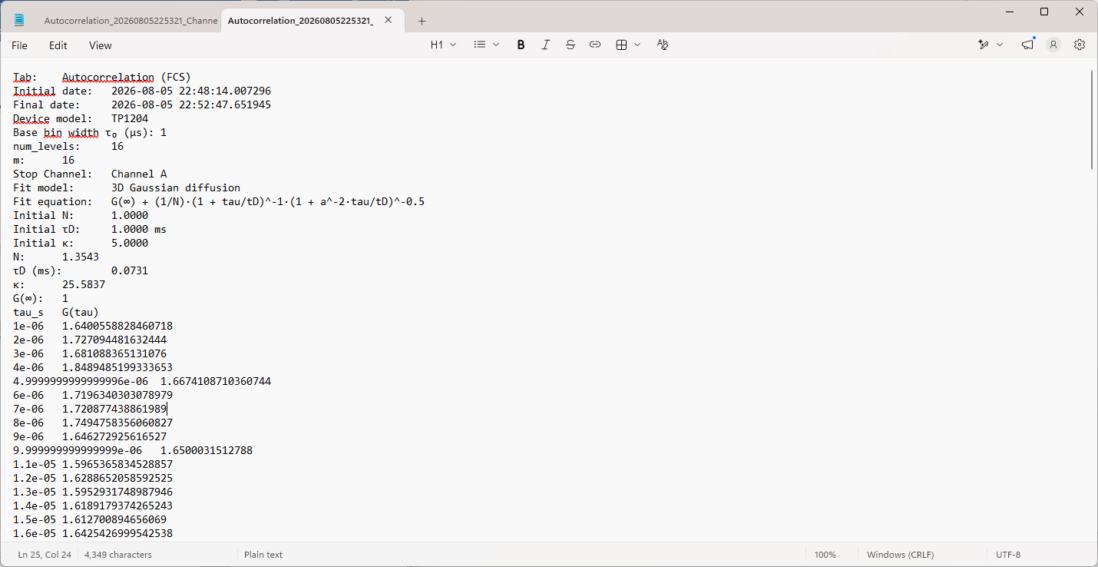
Likewise, the Save Plot button exports the graph exactly as it appears in screen, including the fitted curve if one was calculated. The available formats are .png, .tiff, and .jpg. In both cases, once the user selects the desired format and confirms, a confirmation window appears indicating that the file was saved successfully and displaying the path where it was stored.
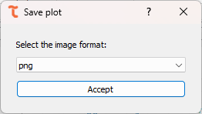

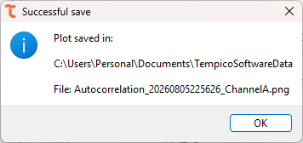

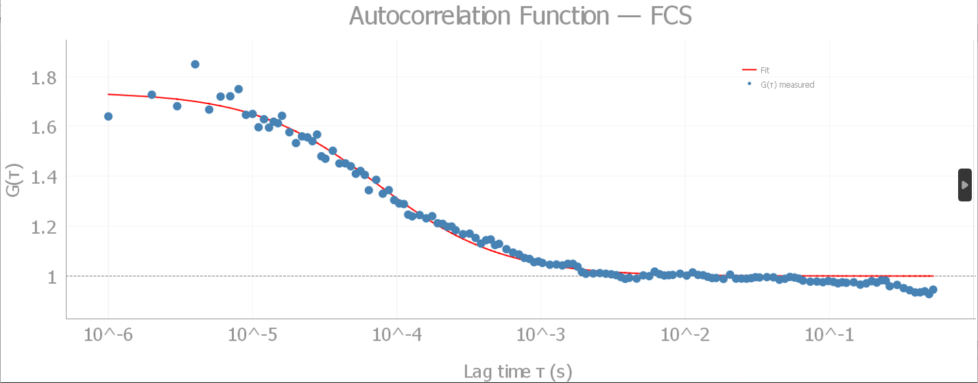

g${}_{​}^{\left(2\right)}​$ (Hanbury Brown and Twiss)
The g⁽²⁾(HBT) tab allows the user to compute the second-order intensity correlation function g⁽²⁾(τ), following a Hanbury Brown-Twiss (HBT) type measurement. The tab builds a symmetric histogram of the delay τ between the start signal and the stop signal recorded on a single channel, normalized so that uncorrelated light gives g⁽²⁾(τ) =1. The shape of this curve around τ=0 reveals the photon statistics of the light source: a dip indicates photon antibunching, typical of single-photon emitters, while a peak indicates bunching, typical of thermal or chaotic light sources.

Settings before measurements
The g⁽²⁾(τ) histogram requires only one valid stop pulse per start cycle, since only the first stop of each cycle is used to computed τ. If the user wants the software to additionally estimate the coincidence rate through the Count Estimation feature, at least 2 stops per cycle are needed so that a stop-to-stop time interval can be computed; in that case, the software automatically requests the extra stop from the device when the corresponding checkbox is enabled, with no additional channel configuration required from the user.
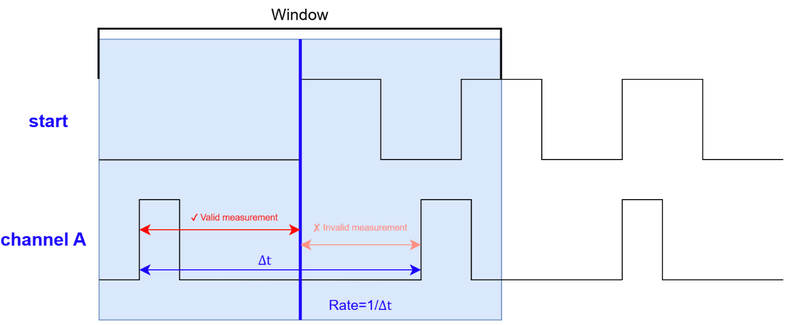
Regarding the acquisition settings, the user must configure the following parameters, located on the left panel of the tab. The Stop Channel dropdown selects the channel (A, B, C, or D) whose delay relative to the start signal will be histogrammed. The Bin width field sets, in nanoseconds, the width of each histogram bin, and can be configured from 0.1 ns up to 10,000 ns. The Window (±) field sets, in nanoseconds, the half-width of the histogram around τ=0, and can be configured from 10 ns up to 100,00 ns; together with the bin width, this defines the total range and resolution of the g⁽²⁾(τ) curve. The user can either set a fixed Duration, from 1 second up to 24 hours, or enable the Continuous measurement checkbox, which ignores the duration value and keeps the histogram running until the user presses Stop. Finally, the Count Estimation checkbox can optionally be enabled before starting the measurement, so a coincidence rate, expressed in counts per second, is estimated and displayed while measuring.
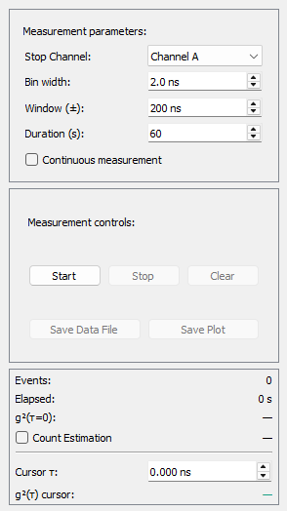

Perform a measurement
Once the desired configuration is selected, click the Start button to begin the acquisition. While the measurement is running, the Stop Channel, the Bin Width, the Window (±), the Duration, and the Continuous measurement and Count Estimation checkboxes are locked and cannot be changed. The g⁽²⁾(τ) histogram is plotted live around a reference line at g ⁽²⁾ =1. At any point the user can press Clear to reset the histogram, or Stop to end the measurement before the configured duration elapses.
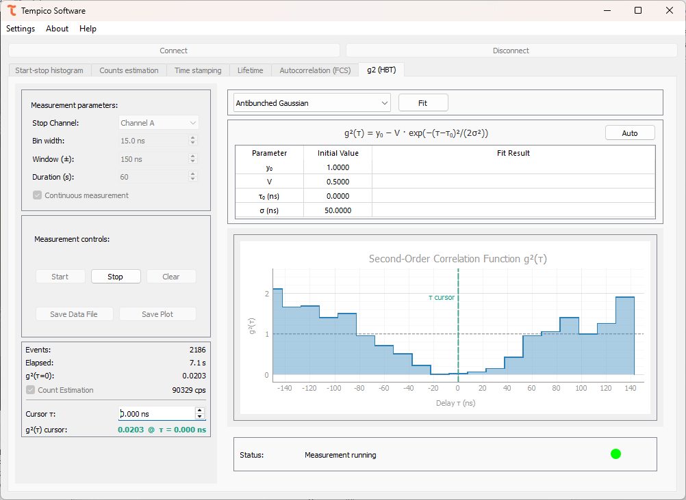

The panel below the settings reports the acquisition progress through two values: Events, which indicates the number of valid stop events detected on the selected channel since the measurement started, and Elapsed, which indicates the elapsed time since the measurement started, shown in seconds and, if applicable, against the total configured duration. If Count Estimation was enabled before starting, this panel also shows the estimated coincidence rate, in counts per second.
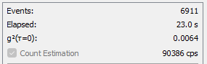

Next to this panel, the Status bar shows a colored dot together with a short descriptive message, which the user should monitor throughout the measurement. A grey dot indicates that no measurement is currently running. A green dot indicates that the measurement is running normally, with the message reporting the current number of events and elapsed time. An orange dot indicates that a warning condition was detected: the message “No measurements in Start Channel” means that the device is not receiving any start pulses, while the message “No measurements in Stop Channel [A/B/C/D]” means that no valid stop pulses are being detected on the selected stop channel. If either warning persists, the user should heck the corresponding cable connections and the signal levels before continuing the measurement.

Post-measurement

Fitting
Once the measurement finishes, the user can fit the g⁽²⁾(τ) histogram to one of five models available in the fit model dropdown, located in the upper-right panel. Selecting model updates the equation shown above the parameter table, which lists an editable Initial value column and a read-only Fit result column. The Auto button restores the initial guesses automatically suggested by the software for the selected model.
Clicking Fit runs the fit and fills the Fit result column; the fitted curve is then overlaid on the histogram. If a reliable value cannot be estimated, the software reports “nan” for that parameter. Since the quality of the fit depends on the initial guesses, the user is free to edit them manually in the Initial value column before running the fit again, or restore the software’s suggested values with the Auto button.
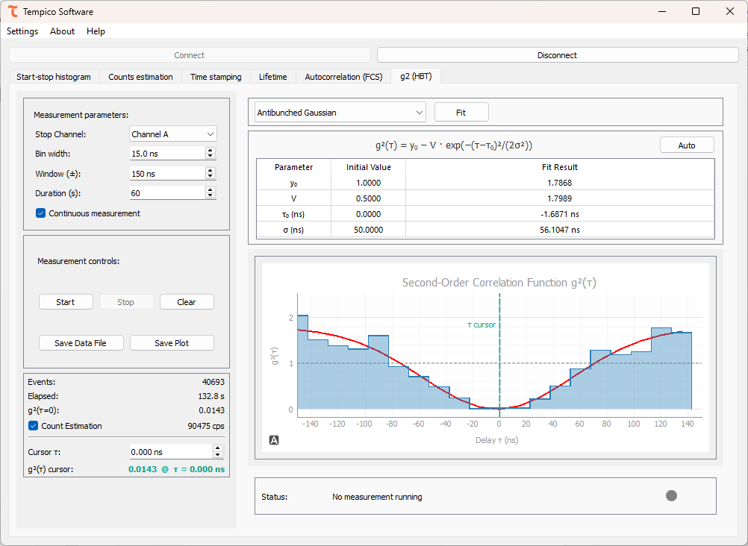

Antibunched Gaussian
$$y_{0}-V∙\exp\left[-\frac{{\left(τ-τ_{0}\right)}^{2}}{2σ^{2}}\right]$$
Describes a dip in g⁽²⁾(τ) with a Gaussian profile, characteristic of a single-photon emitter with Gaussian-broadened timing jitter. The fitted parameters are y₀, the baseline level far from τ=0; V, the dip depth; τ₀, the position of the dip, in ns; and σ, the width of the Gaussian dip, in ns.

Antibunched Lorentzian
$$y_{0}-V∙\frac{{\left(\frac{Γ}{2}\right)}^{2}}{{\left(τ-τ_{0}\right)}^{2}+{\left(\frac{Γ}{2}\right)}^{2}}$$
Describes a dip in g⁽²⁾(τ) with a Lorentzian profile, typical of a single emitter with an exponential excited-state lifetime. The fitted parameters are y₀, the baseline level; V, the dip depth; τ₀, the position of the dip, in ns; and $Γ$, the full width at half maximum of the Lorentzian dip, in ns.

Bunched Gaussian
$$y_{0}-a∙\exp\left[-{\frac{π\left|τ-τ_{0}\right|}{τ_{c}}}^{2} \right]$$
Describes a peak in g ⁽²⁾ with an exponential profile, also typical of bunched or thermal light. The fitted parameters are y₀, the baseline level; α, the peak amplitude; τ₀, the position of the peak, in ns; and τ_{c}, the coherence time governing the width of the Gaussian peak, in ns.

Bunched Lorentzian
$$y_{0}-a∙\exp\left[-\frac{\left|τ-τ_{0}\right|}{τ_{c}} \right]$$
Describes a peak in g⁽²⁾(τ) with an exponential profile, also typical of bunched or thermal light but with a different decay shape than the Gaussian case. The fitted parameters are y₀, the baseline level; α, the peak amplitude; τ₀, the position of the peak, in ns; and τ_{c}, the coherence time governing the decay of the peak, in ns.

Three-level system
$$1-\left(1+a\right)∙\exp\left[-\frac{\left|τ-τ_{0}\right|}{τ_{1}}\right]+a∙\exp\left[-\frac{\left|τ-τ_{0}\right|}{τ_{2}}\right]$$
Describes the g⁽²⁾(τ) response of an emitter with an additional metastable (shelving) state, combining an antibunching dip with a bunching shoulder. The fitted parameter are a, the relative amplitude of the bunching shoulder; τ₀, the position of the feature, in ns; τ₁, the fast time constant associated with the antibunching dip, in ns; and τ₂, the slow time constant associated with shelving-state bunching, in ns.

Save data
Once the measurement finishes, the Save Data File button is enabled. Clicking it opens a dialog window where the user selects the file format: .txt, .csv, or .dat. Two files are generated: one containing the raw start-stop times recorded during the acquisition, and another with the analyzed g ⁽²⁾ curve, listing τ in nanoseconds and the corresponding g ⁽²⁾ value. Both files share a header with the measurement window, the device model, the measurement parameters, and the selected stop channel; if a fit was performed, the fit model, its equation, and the resulting parameter values are also included in the header.
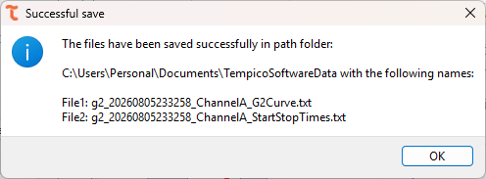

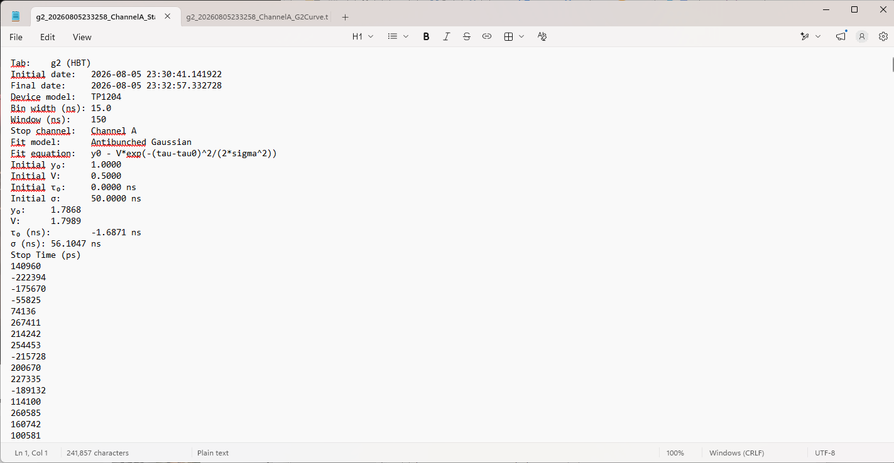
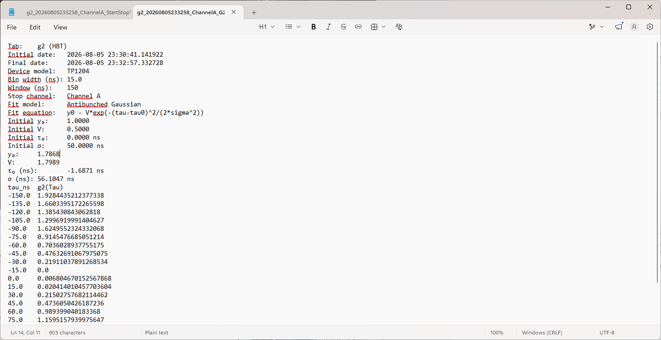
Likewise, the Save Plot button exports the graph exactly as it appears on screen, including the fitted curve if one was calculated. The available formats are .png, .tiff, and .jpg. In both cases, once the user selects the desired format and confirms, a confirmation window appears indicating that the file was saved successfully and displaying the path where it was stored.
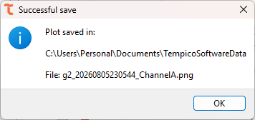
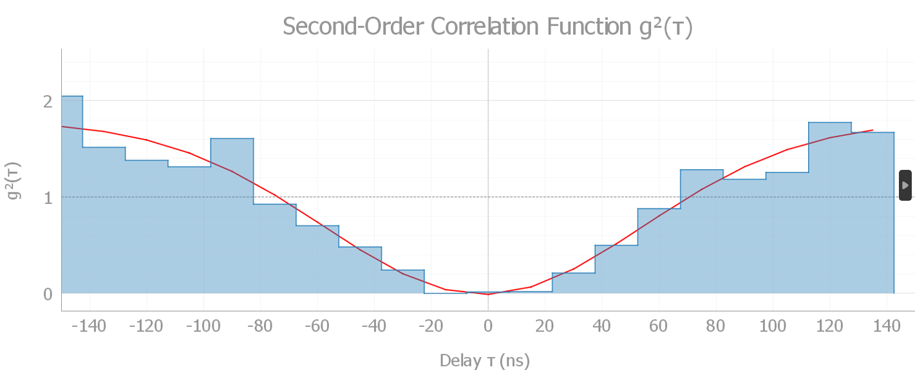

Technical documentation
Tempico Software is open source, allowing access to the software's source code and developer documentation through the GitHub platform. It also provides a guide to the code and the creation of respective installers for each operating system.
https://github.com/Tausand-dev/TempicoSoftware

Drivers
Your computer may automatically download and install from the Internet the required drivers once you connect your Tausand Tempico device to a USB port. If you require to install them manually, they are available at https://www.tausand.com/downloads.

Technical support
For technical support, contact us at support@tausand.com.
Visit our website to check for the latest documentation and software releases.
www.tausand.com

